Report

|  |  |
| --- | --- |
| **Subject** | Planning Proposal to amend Schedule 1 of the Lismore Local Environmental Plan 2012 to allow an additional permitted use at 464 Broadwater Road, Dungarubba |
| **TRIM Record No** | BP19/1227:AF19/3461 |
| **Prepared by** | Trainee Development Assessment Planner |
| **Reason** | To seek a Council resolution to support a Planning Proposal to amend Scedule 1 of the LEP to allow an additional permitted use (erosion mat manufacturing) at 464 Broadwater Road, Dungarubba and seek a Gateway Determination from the Department of Planning, Industry and Environment. |
| **Strategic Theme** | Our built environment |
| **Strategy** | Our land-use planning caters for all sectors of the community. |
| **Action** | Ensure a diverse range of land use and development opportunities are available. |

|  |
| --- |
| Executive Summary On 5 August 2019, a Planning Proposal was received to amend Schedule 1 of the Lismore Local Environmental Plan 2012 (LEP) to allow additional permitted uses on part of the land at 464 Broadwater Road, Dungarubba (Lot 3 DP 593867).  The amendment would allow a development application (DA) to be lodged and assessed for a General Industry (erosion mat manufacturing) which is prohibited in zone RU1 (Primary Production).  The production process of the concrete erosion mats has specific and unique requirements in that a flat linear surface 24 metres wide and greater than 500 metres in length is required. No land zoned for industrial use within the Lismore Local Government Area meets the operational and logistic requirements of the proposed business.  An assessment of constraints such as land contamination, acid sulfate soils, flooding and land use conflict has not revealed any impediments that cannot be resolved or the need for further technical reporting.  It is recommended that Council support the attached Planning Proposal and forward it to the Department of Planning and Environment requesting a Gateway Determination. |

*Do not delete this line*

Recommendation

|  |
| --- |
| That Council:   1. support the Planning Proposal to amend Schedule 1 of the Lismore Local Environment Plan 2012, as detailed in Attachment 1 of this report, to allow an additional permitted use described as *General Industry (manufacturing of concrete erosion mats)* on part of the land at 464 Broadwater Road, Dungarubba (Lot 3 DP 593867) for the purposes of seeking a Gateway Determination; 2. forward the Planning Proposal to the Department of Planning, Industry and Environment with a request for a Gateway Determination; 3. agree that staff place the Planning Proposal on public exhibition and consult with government agencies in accordance with a Gateway Determination and report back to Council any issues raised by government agencies and in public submissions during public exhibition. |

*Do not delete this line*

Background

On 5 August 2019, a draft Planning Proposal was received to amend Schedule 1 of the Lismore Local Environmental Plan 2012 (LEP) to allow additional permitted uses on part of the land at 464 Broadwater Road, Dungarubba (Lot 3 DP 593867).

The land is zoned RU1 Primary Production and the additional permitted use being sought is the production of a concrete erosion mat product which is considered to be a General Industry under the Lismore LEP, which is prohibited within the RU1 zone.

A general Industry is defined in the LEP as;

*a building or place (other than a heavy industry or light industry) that is used to carry out an industrial activity.*

An industrial activity is defined in the LEP as;

*the manufacturing, production, assembling, altering, formulating, repairing, renovating, ornamenting, finishing, cleaning, washing, dismantling, transforming, processing, recycling, adapting or servicing of, or the research and development of, any goods, substances, food, products or articles for commercial purposes, and includes any storage or transportation associated with any such activity.*

The production process of the erosion mats has specific and unique requirements in that a flat linear surface 24 metres wide and greater than 500 metres in length is required, as shown in the images in Figure 1 below. No land zoned for industrial use within the Lismore LGA meets the operational and logistic requirements of the proposed business. Nor is there any suitable land identified for future industry in Council’s Growth Management Strategy. The applicant undertook a pre-lodgement meeting with Council staff and was advised that due to the unique characteristics of the site requirements for the proposal, a Planning Proposal to amend the LEP for a site-specific use would be required.

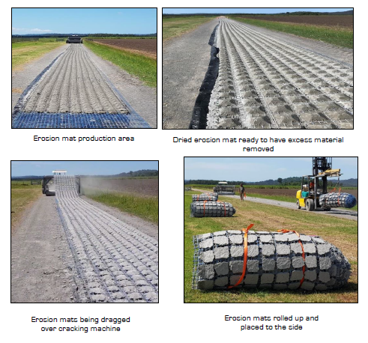

**Figure 1: Images demonstrating site requirements for erosion mat production.**

Location and Characteristics of the subject site

The subject land is located approximately 30 kilometres by road south of Lismore’s urban area. The land is zoned RU1 and has an area of 42.21 hectares with frontage to Broadwater Road, Dungarubba. The land is currently used for sugar cane and cattle farming. As shown in Figure 2 below, the surrounding land is all zoned RU1. Adjoining land uses are predominantly sugar cane cropping and cattle grazing with rural dwellings interspersed throughout. A rural lifestyle lot of 2 hectares adjoins the land directly to the south at 444 Broadwater Road. Further west at 354 Broadwater Road (Lot 2 DP 8877) is an approved industrial activity for the manufacturing of concrete posts that was previously enabled via a previous Planning Proposal and approved under DA15/357.

The property includes a redundant farm access driveway that is intended to be utilised for the purpose of the erosion mat manufacturing process. The area required for the proposed industrial use is approximately 3.3 hectares as shown in Figure 3 below and includes an area of closed Crown road that the applicant has indicated they are investigating purchasing from the Crown.

The land has been cleared of vegetation and therefore contains no koala habitat or other high conservation value areas. The site is not mapped as containing bushfire prone vegetation.

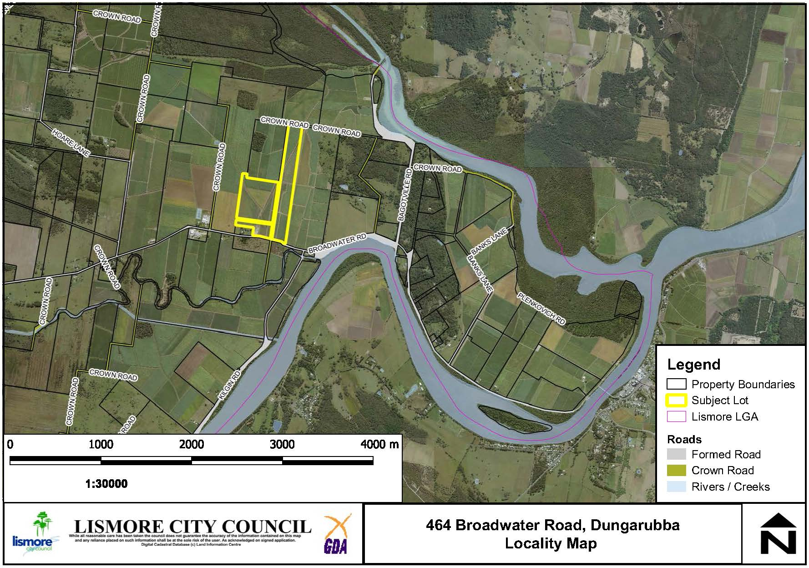

**Figure 2: Subject site and locality.**

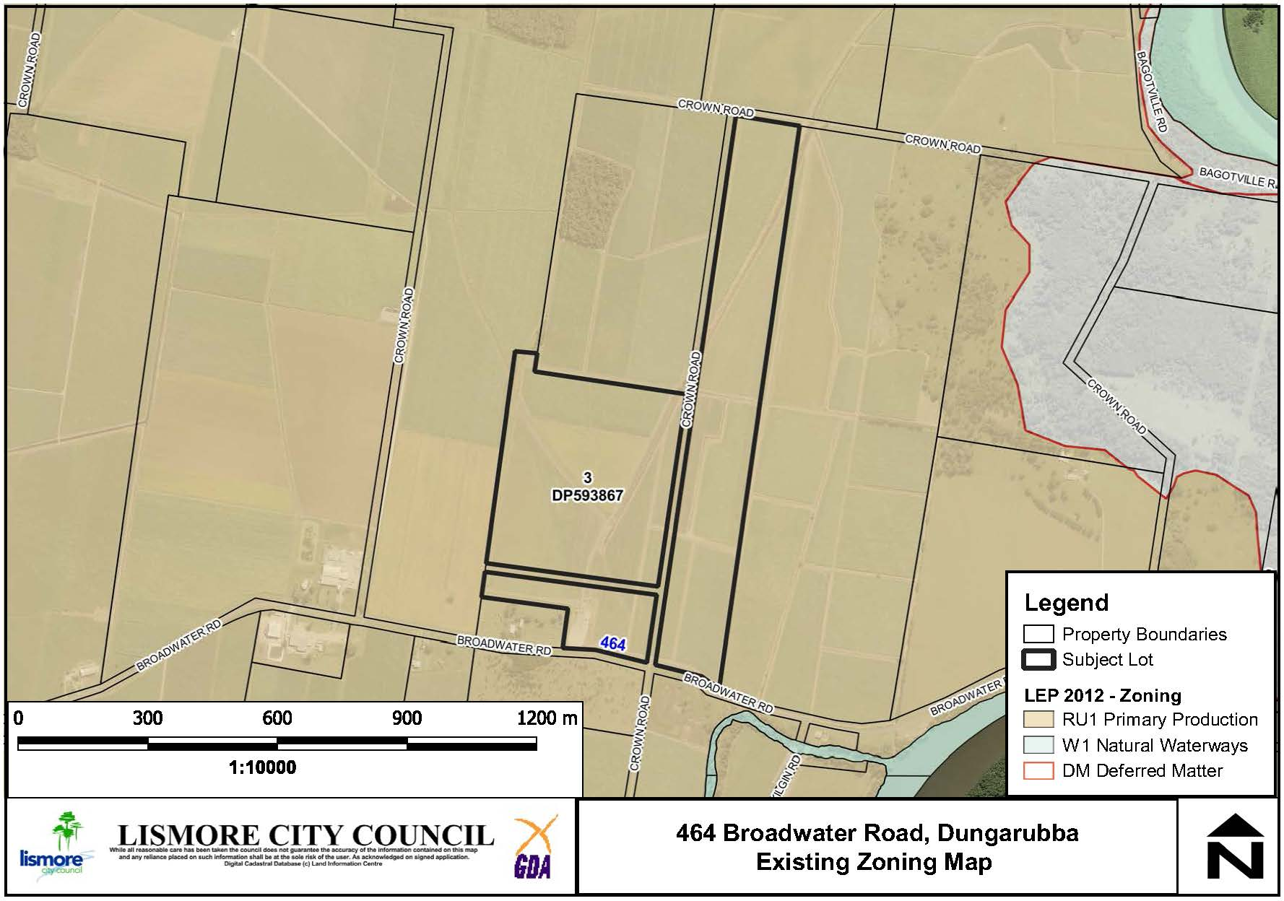

**Figure 3: Lismore LEP zoning for 464 Broadwater Road and surrounding properties.**

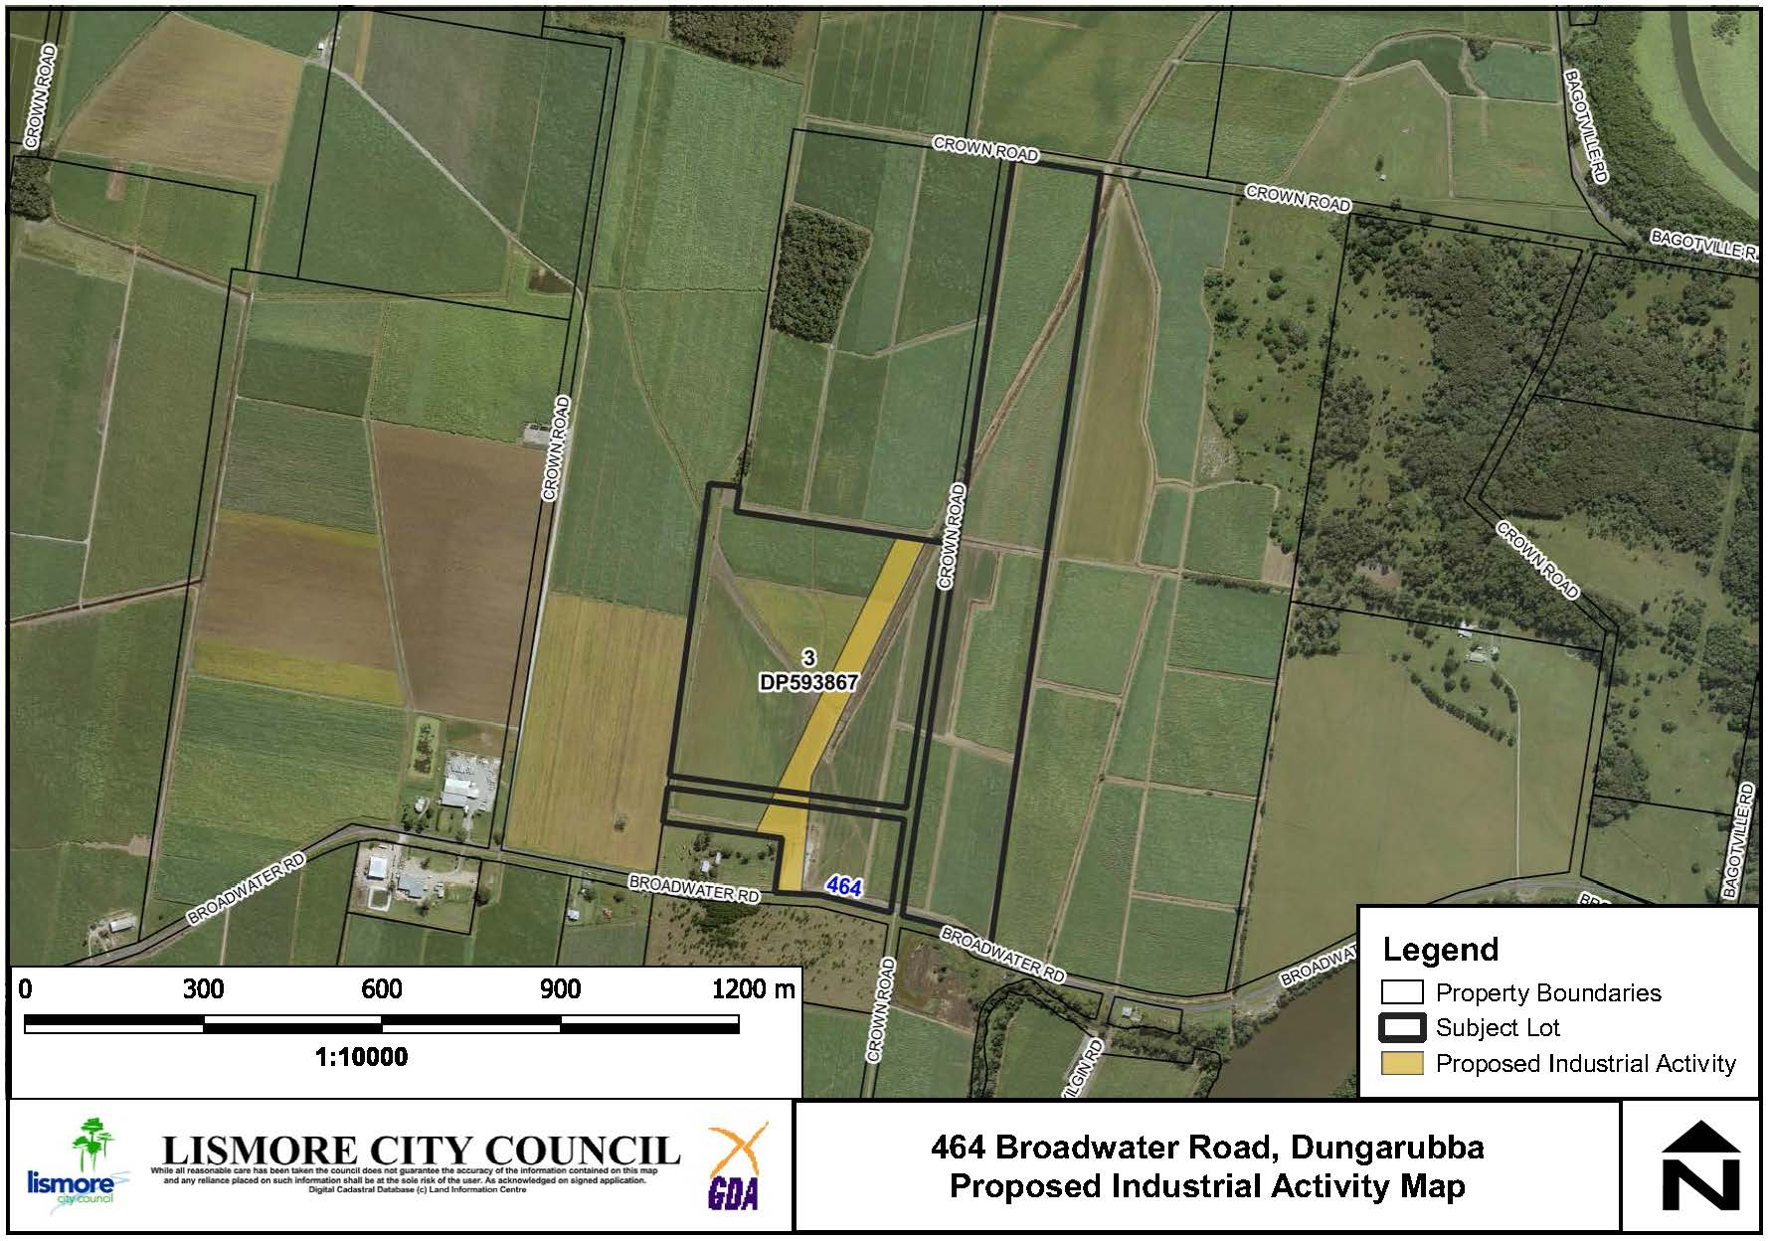

**Figure 4: Area of the proposed industrial activity at 464 Broadwater Road.**

Environmental, Social and Economic Impact Assessment

Environmental and physical constraints

**Contaminated Land**

The site is identified within Council’s GIS mapping as being potentially contaminated land as a result of the current sugar cane use. Council’s Environmental Health staff has advised the nature of the proposed land use will not trigger the requirement for any further technical reporting by way of a preliminary contaminated land assessment as the activity will be undertaken on imported hard stand areas and there will be no disturbance of the soil environment.

**Acid Sulphate Soils**

The area is mapped as containing Class 3 Acid Sulfate Soils. No significant earthworks are proposed to be undertaken to facilitate operations and Council’s Environmental Health staff has advised no technical reporting on this matter is required. The relevant provision of the LEP will be addressed with any subsequent development application.

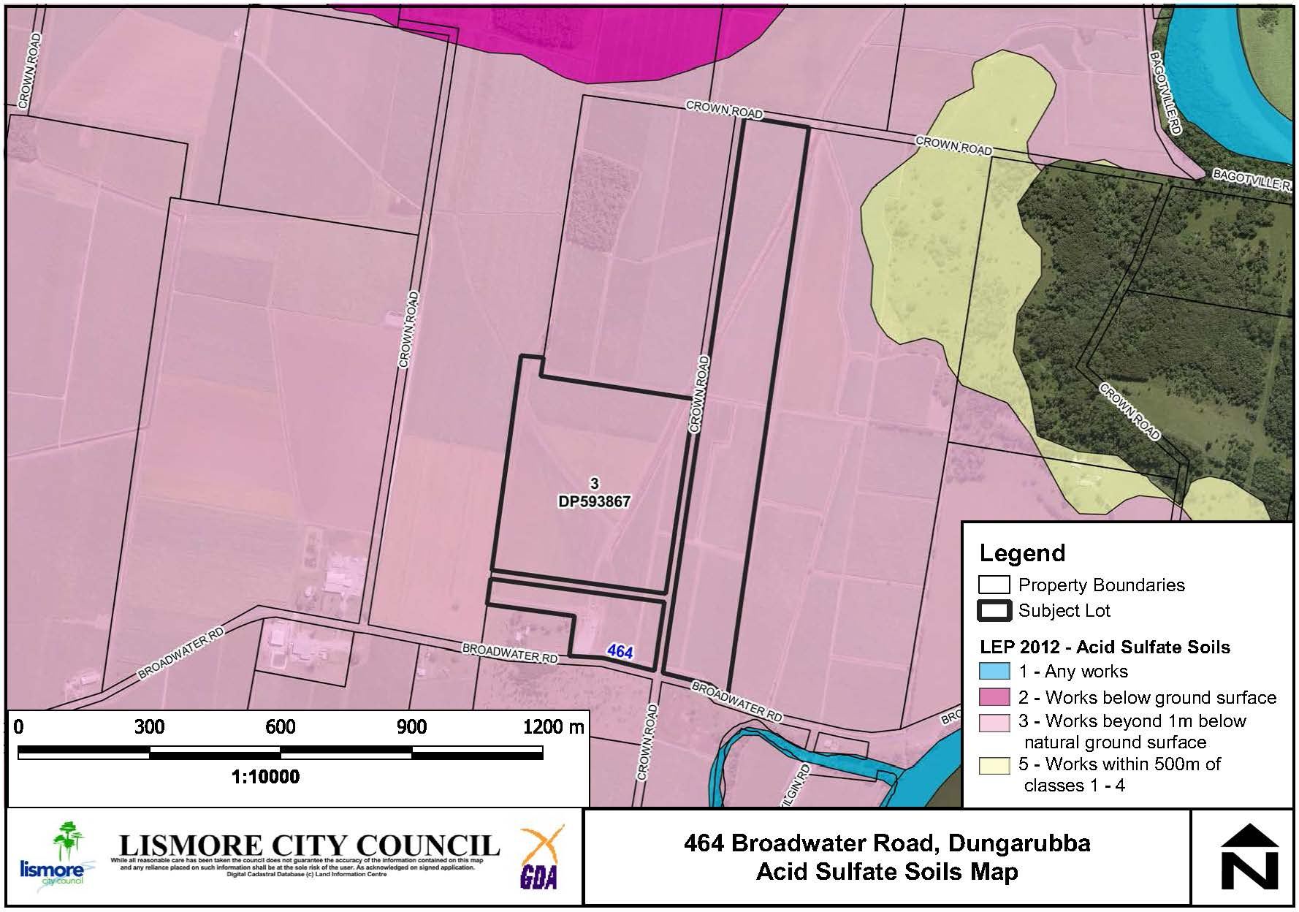

**Figure 5: Acid Sulfate Soils**

**Flooding**

The land is prone to flooding. The relevant provisions of the LEP can be addressed with any subsequent development application.

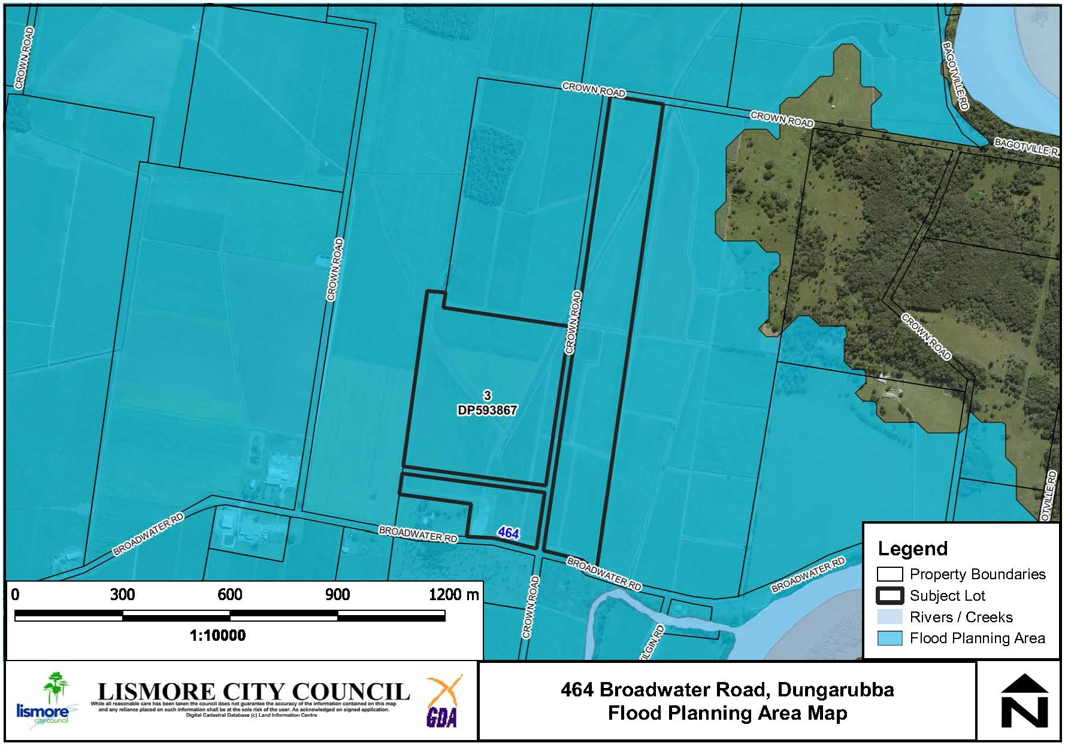

**Figure 6: Flood Planning Area**

**Buffers to Watercourses**

The site is not within the drinking water catchment. Council mapping indicates an Order 1 stream running in a north west-south east direction on the western side of the property and an Order 8 stream running adjacent to the driveway proposed to be utilised for the manufacturing area of the erosion mats. There is an existing drainage channel under the road proposed to be used for the construction of erosion mats that will not be impacted by the proposed land use. Therefore, the existing flow of water will not be impacted. The impact from washdown waters and other waste is considered to be very low and can be addressed through conditions such as a requirement for a retention pond and filtering with any subsequent development application.

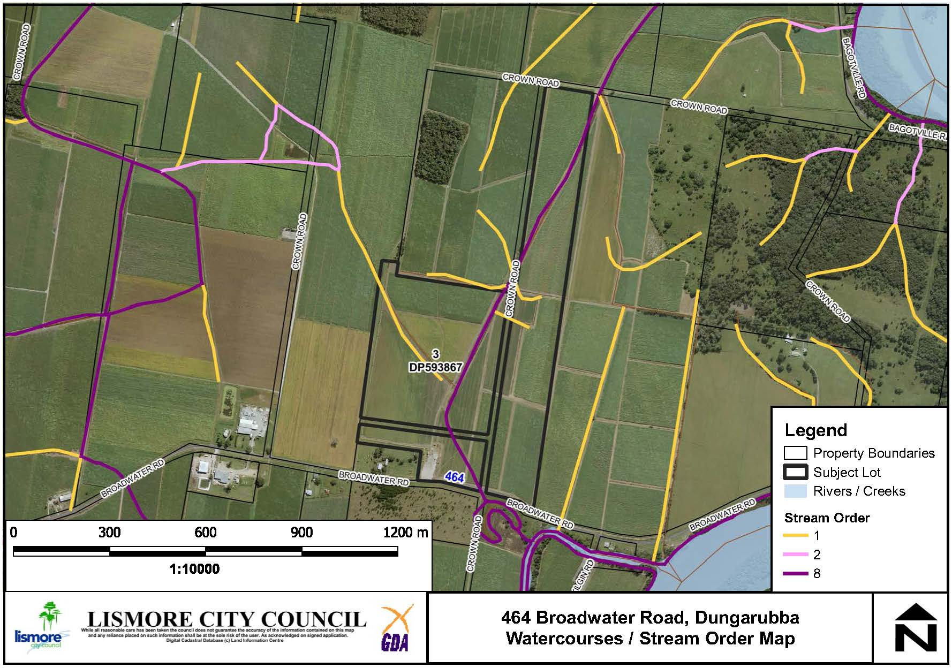

**Figure 7: Existing watercourses**

**Land Use Conflict (Noise and dust)**

A Land Use Conflict Risk Assessment (LUCRA) has been undertaken by the applicant. A map showing surrounding land uses was provided (See Figure 8 below) and the LUCRA evaluated risks from noise and dust.

The nearest dwelling is located approximately 160m from the proposed industrial activity. Council’s DCP recommends a buffer of 40m from general industries to residential lots. The buffers prescribed by Council’s DCP have been assessed and this proposal is shown to meet requirements. Furthermore, a range of management mitigation measures have been identified including hours of operation, which can be addressed with any subsequent development application.

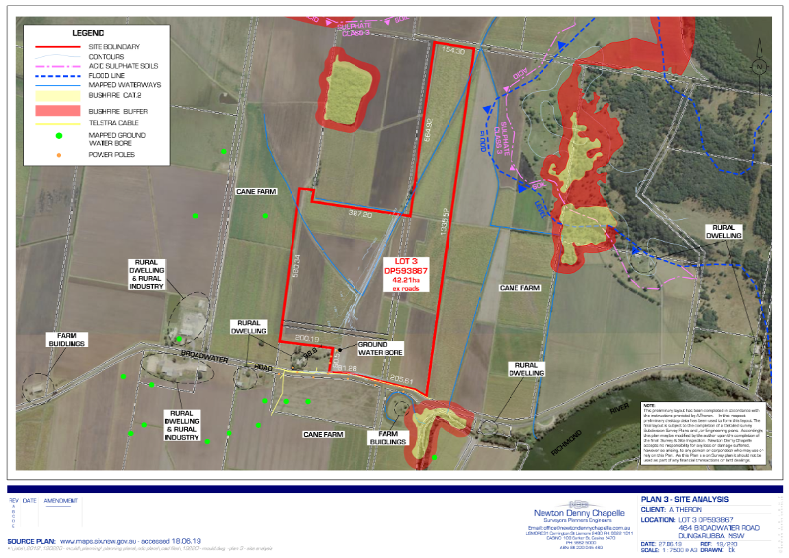

**Figure 8: Surrounding land uses**

**Regionally Significant Farmland**

The site is mapped as regionally significant farmland**.** The proposal is for an area of 3.3 hectares to be utilised for a General Industry, with the remaining 39 hectares to continue to be used for productive agriculture. The applicant has indicated the majority of the land will be planted with macadamias. The Planning Proposal will not remove any land from the RU1 zone in the Lismore LEP 2012 and it is anticipated that the impacts of the proposed industrial use are considered negligible on the agricultural use of the land.

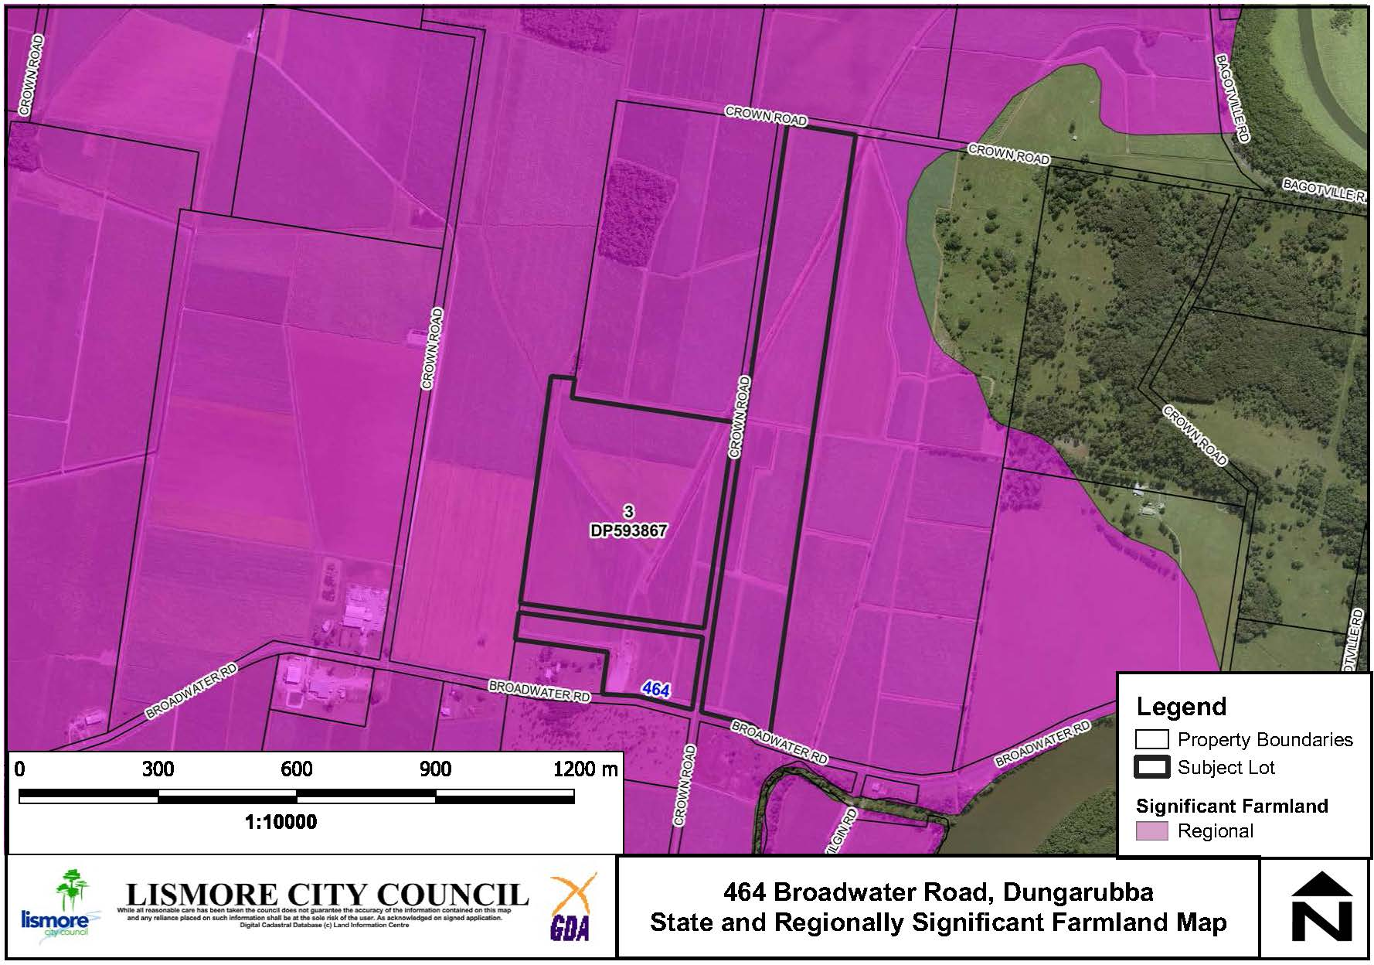

**Figure 9: Regionally Significant Farmland.**

Social, economic and cultural heritage impacts

**Aboriginal and European Cultural Heritage**

An AHIMS search was undertaken and no Aboriginal sites or places were identified within 50 metres of the subject land. The land is also not listed as a heritage item in Schedule 5 of the Lismore LEP 2012.

**Social and Economic Impact**

A LUCRA has been prepared and demonstrated that the impact of the proposed development on surrounding dwellings will be low and can be adequately managed. The proposal does not trigger the requirement for a Social Impact Assessment (SIA) under section 5.3 of the LCC SIA guidelines.

The Planning Proposal will permit a manufacturing industry on the site that will provide economic benefits associated with the ongoing employment of six (6) staff. The proposal does not displace any employment lands and will not negatively impact upon other employment centres.

Servicing and infrastructure

**Road Network**

The proposed activity will require deliveries of premixed concrete (nominal 18m3 – i.e. 3 trucks) per daily pour. A visual condition assessment was undertaken during the site inspection by Council’s consultant strategic engineer, with the existing road network assessed as being suitable to cater for this low volume of heavy vehicles. Existing Broadwater Road is a local collector road and is of good condition with 7m seal width. This road has been subject to upgrades via Building Better Regions road funding over several years. Wyrallah Road is a regional road and is also in a good to fair condition to service the facility in its function as a transport corridor.

The nature of the proposal will not require any additional services in relation to water, sewer, power or telephone/NBN.

Overview of the Planning Proposal

The Planning Proposal seeks to amend the LEP written instrument as follows:

* Amend **Schedule 1 Additional Permitted Uses** of the Lismore LEP 2012 to permit additional uses on part of 464 Broadwater Road, Dungarubba (Lot 3 DP 593867). The proposed insertion is:

***7 Use of certain land at 464 Broadwater Road, Dungarubba***

1. *This clause applies to part of the land at 464 Broadwater Road, Dungarubba, being part Lot 3, DP 593867 identified as “Item 7” on the Additional Permitted Uses Map.*
2. *Development for the purpose of a General Industry (limited to the manufacturing of concrete erosion mats) is permitted with development consent on the land to which this clause applies:*

The following Map sheet is proposed for amendment:

* Additional Permitted Uses Map – to identify part of 464 Broadwater Road, Dungarubba (Part of Lot 3 DP 593867) as Item 7.

Table 1 provides a summary of the planning proposal.

**Table 1: Summary of Planning Proposal**

| **PART** | **REQUIREMENTS** | **DESCRIPTION OF PLANNING PROPOSAL** |
| --- | --- | --- |
| 1 | **OBJECTIVES OR INTENDED OUTCOMES** | The objective of the planning proposal is to allow for additional permitted uses at part of 464 Broadwater Road, Dungarubba (Lot 3 DP 593867) |
| 2 | **EXPLANATION OF PROVISIONS** | The planning proposal seeks to amend the following parts of the Lismore LEP 2012:   * Additional Permitted Uses Map - APU_006C * Amend Schedule 1 Additional Permitted Uses of the Lismore LEP to allow additional permitted uses at part of 464 Broadwater Road, Dungarubba (Lot 3 DP 593867). |
| 3 | **JUSTIFICATION**  **Section A- Need for the Planning Proposal**  ***Is the planning proposal a result of any strategic study or report?***  ***Is the planning proposal the best means of achieving the objectives or intended outcomes, or is there a better way?*** | The Planning Proposal to amend Schedule 1 Additional Permitted Uses of the Lismore LEP 2012 is the most practical method of achieving the aim of enabling the further development of the site for Erosion Mat manufacturing that is currently prohibited in Zone RU1 Primary Production.  This outcome is preferred to a rezoning of the site because Zone RU1 Primary Production remains an appropriate zone on the land given it is surrounded by similar agricultural land uses and the remainder of the land will continue to be used for agricultural purposes. Under the Lismore LEP 2012, a General Industry is permitted with consent in Zone IN1 General Industrial, however rezoning the site to an industrial zone is not considered appropriate given the rural location and surrounding land uses that are predominately agricultural and ancillary rural residential in association with farming activities. |
| 4 | **JUSTIFICATION**  **Section B- Relationship to Strategic Planning Framework**  ***Is the Planning Proposal consistent with the objectives and actions contained within the applicable regional or sub-regional strategy?***  ***Is the Planning Proposal consistent with the Council’s local strategy or other local strategic plan?***  ***Is the Planning Proposal consistent with applicable State Environmental Planning Policies (SEPP)?***  ***Is the Planning Proposal consistent with applicable s9.1 Ministerial Directions?*** | While the subject site is not identified as an investigation area for employment land in the North Coast Regional Plan (NCRP) 2036, this Planning Proposal reinforces the following directions:  **Direction 6: Develop Successful Centres of Employment –** the Planning Proposal will permit a new industrial use on the site and facilitate the ongoing employment of approximately six (6) staff.  **Direction 11: Protect and Enhance Productive Agricultural** Lands – The site is mapped as being regionally significant farmland. The Planning Proposal seeks to utilize a redundant internal driveway together with the existing cane pad at the front of the property for access. The balance of the property will be retained for farming activities and the applicant has indicated an intention to plant macadamia trees on the remaining land. The Planning Proposal will not remove any land from the RU1 zone in the Lismore LEP 2012.  While the subject site is not identified as either existing employment land or investigation area – employment land in the Lismore Growth Management Strategy, the Planning Proposal is not expected to have any impact on the availability of industrial zoned employment land in the longer term.  The planning proposal is consistent with the Lismore City Council Delivery Program 2017 - 2021 Strategy “Ensure a diverse range of land use and development opportunities are available”.  This proposal is consistent with the relevant SEPP’s as outlined in Attachment 1.  This proposal is consistent, or any inconsistency can be justified with applicable s9.1 Ministerial Directions as outlined in Attachment 1. |
| 5 | **JUSTIFICATION**  **Section C- Environment, Social and Economic Impact**  ***Is there any likelihood that critical habitat of threatened species, populations or ecological communities or their habitats, will be adversely affected as a result of the proposal?***  ***Are there any likely environmental effects as a result of the Planning Proposal and how are they proposed to be managed?***  ***Has the Planning Proposal adequately addressed any social and economic effects?*** | The land subject to this Planning Proposal has been previously cleared of vegetation and is not identified as containing any areas for koala habitat or high biodiversity values. It is therefore unlikely that this proposal will adversely affect any critical habitat, threatened species, populations or ecological communities or their habitats.  Acid Sulfate Soil and Flood Planning issues can be satisfactorily addressed post-Gateway by the relevant clauses within the Lismore LEP. A LUCRA has been undertaken and assessed as satisfactorily demonstrating that noise and dust issues from the proposed land use presents a low risk to adjoining land uses and can be mitigated via operational hours.  A search of the Aboriginal Heritage Information Management System (AHIMS) was undertaken and did not identify any Aboriginal sites or places on the subject land. The land is also not subject to any listings of environmental heritage items or archaeological sites pursuant to Schedule 5 of the LEP 2012.  With regard to economic impacts, the applicant has indicated that the business will employ approximately 6 staff. |
| 6 | **JUSTIFICATION**  **Section D - State and Commonwealth Interests**  ***Is there adequate public infrastructure for the Planning Proposal?***  ***What are the views of State and Commonwealth public authorities consulted in accordance with the Gateway Determination?*** | Council staff have carried out a preliminary assessment of public infrastructure and determined that the existing road network is sufficient to cater to the low level of heavy vehicles expected to be generated by the proposed activity. No other additional services are required.  It is proposed that the Government Agency/organisations listed below are consulted as part of the public exhibition of the Planning Proposal:   * Roads and Maritime Services * Natural Resource Access Regulator (Land and Water Division) |
| 7 | **MAPPING** | It is proposed to amend the LEP map as shown in the next section of this report. |
| 8 | **COMMUNITY CONSULTATION** | A 28-day community consultation period is recommended but this will be confirmed in the Gateway determination. |
| 9 | **PROJECT TIMELINE** | Recommendation of approximately 9 months to complete.  Refer to Attachment 1 for detail. |
| 10 | **DELEGATIONS** | Recommendation for Council to exercise plan making delegations. |

Local Environmental Plan Map

The proposed LEP map is shown in Figure 9 below.

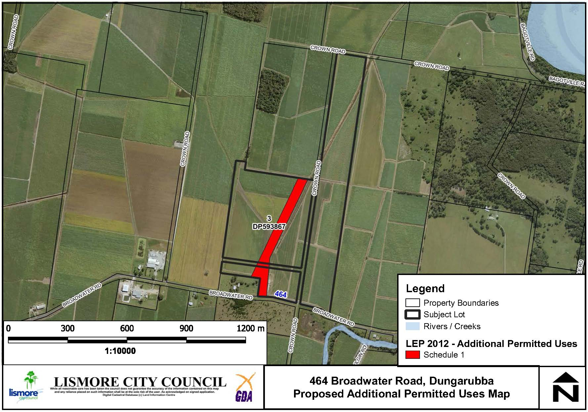

**Figure 9: Proposed APU LEP Map – 464 Broadwater Road, Dungarubba**

Comments

Finance

N/A.

Other staff comments

Council’s specialist staff have assessed the Planning Proposal as required and their comments are incorporated into the relevant sections of this report.

Public consultation

Council will carry out consultation with the community following Gateway Determination. For the purposes of public notification, Council considers that a fourteen (14) day public exhibition period is appropriate.

Notification of the exhibited Planning Proposal will include:

* A newspaper advertisement (Local Matters) that circulates in the area affected by the Planning Proposal.
* The website of Lismore City Council and the Department of Planning, Industry and Environment.
* Letter to adjoining landholders.

The written notice will:

* Provide a brief description of the objectives or intended outcomes of the Planning Proposal.
* Indicate the land that is the subject of the Planning Proposal.
* State where and when the Planning Proposal can be inspected.
* Provide detail that will enable members of the community to make a submission.

Exhibition Material:

* The Planning Proposal, in the form approved for community consultation by the Director General of the Department of Planning, Industry and Environment.
* The Gateway Determination.
* Any studies required as part of the Planning Proposal.

The Gateway Determination will confirm the public consultation requirements.

LEP delegations

Council resolved at its ordinary meeting of 11 December 2012 to accept the delegations which enable it to process the final stages of a planning proposal (LEP amendment). The delegations only extend to minor and routine LEPs. Delegations will be confirmed as part of the Gateway determination.

Conclusion

A preliminary assessment of the Planning Proposal and a constraints analysis of the subject site has not revealed any impediments to the approval of the proposed Schedule 1 Amendment to the Lismore LEP 2012 to identify an additional use (erosion mat manufacturing) to be permitted. The Planning Proposal is generally consistent with relevant State Environmental Planning Policies and s9.1 Ministerial Directions and any inconsistencies can be justified. There is sufficient information to enable Council to support the Planning Proposal and forward it to the Department of Planning and Environment for a Gateway Determination.

*Do not delete this line*

## Attachment/s

|  |  |  |
| --- | --- | --- |
| 1. | Draft Planning Proposal 464 Broadwater Road | (Over 7 pages) |